How to add a port number in the SmarterMail 16.
SmarterMail servers support both POP and IMAP protocols for incoming mail servers and SMTP via submission ports for outgoing mail.
Standard Non-SSL ports can be used:
POP3: 110
IMAP: 143
SMTP: 587 (Submission port)
SSL ports are recommended: POP3: 995
IMAP: 993
SMTP: 465 (Submission port)
SSL/TLS are security protocols that allow the transmission of data to be encrypted. This allows users to access email through a third-party email client without the fear that someone has intercepted their data. SSL will encrypt the connection immediately upon connection. TLS will encrypt once the STARTTLS command is sent. TLS will need to be set up over port 25, 110, 143 and SSL over ports 465, 993, and 995.
Below are the steps to add port number from the SmarterMail 16.
- Login into SmarterMail 16 dashboard with the domain administrator user.
- Click on the Settings icon.
- Click the Bindings from the left-hand side, click Ports from the right-hand side pane.
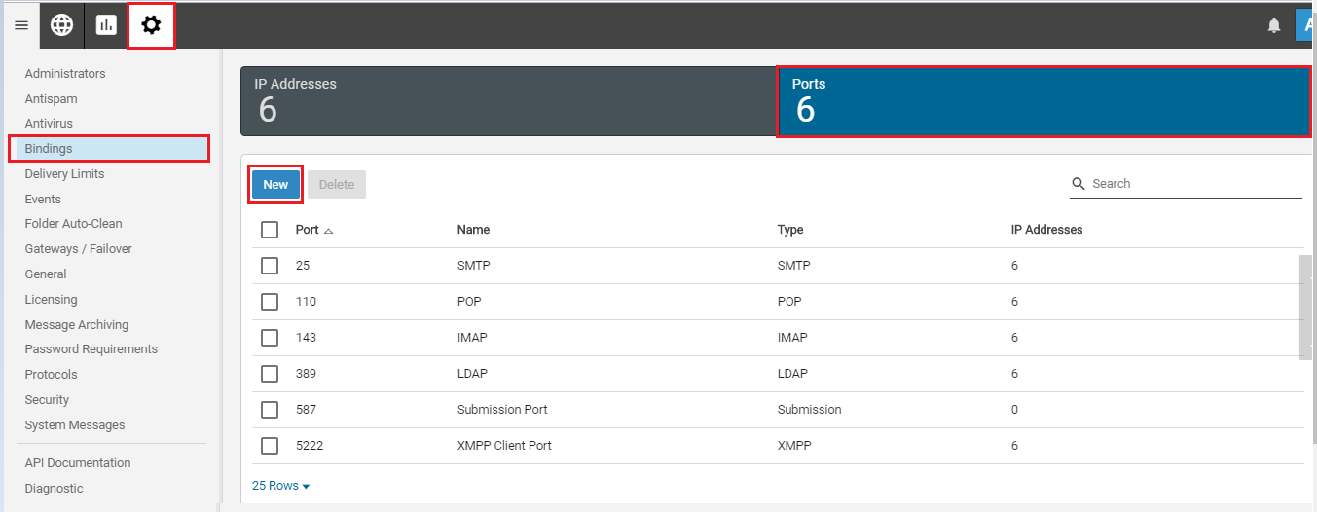
- Without SSL/TLS:
  - Click on the New button. A popup window will display.
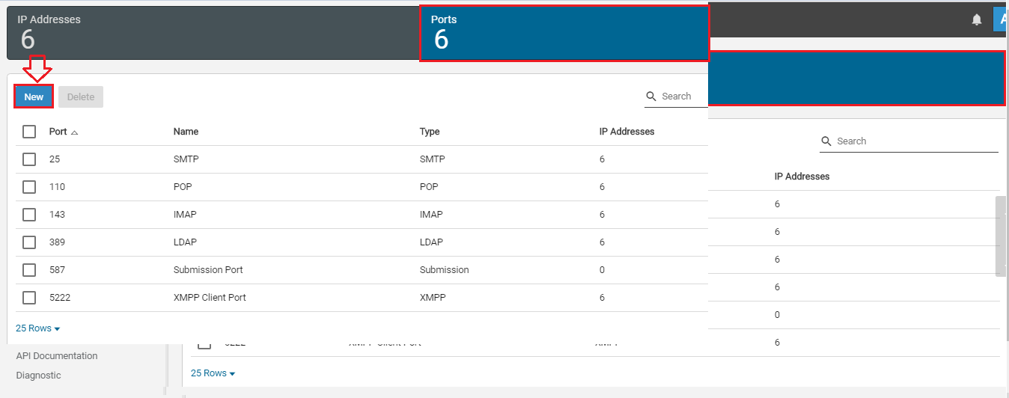
- Enter required fields; Protocol, Encryption (NONE), Name, Port.
- Use the checkboxes to select the IP address to listen on.
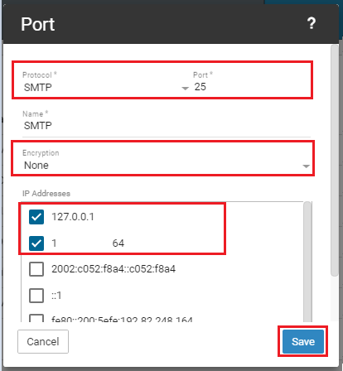

- Click on Save button.
- Using the above steps, add POP3, SMTP and IMAP ports.

- With SSL/TLS:

- Click on the New button. A popup window will display.
- Enter required fields; Protocol, Encryption (SSL or TLS), Name, Port, Path of Certificate and Password of the certificate.
- Make sure the certificate exists in the specified path you have entered.
- Use the checkboxes to select the IP address to listen on.
- Click on Save button.
- Using the above steps, add POP3, SMTP and IMAP ports to be encrypted with SSL or TLS.
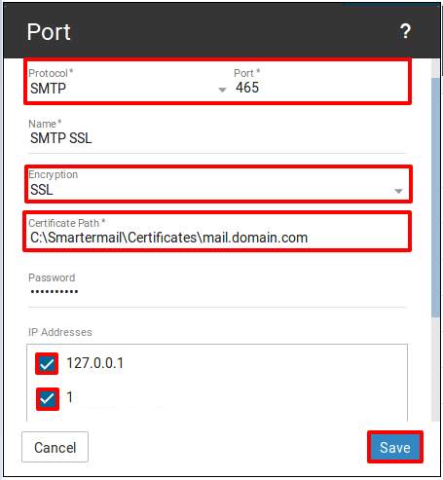
NOTE: Before performing the above steps (With SSL/TLS), you will have to purchase SSL certificate from SSL provider and have to it installed and configured on your VPS.
4. Restart SmarterMail service.

