How to add an email account in SmarterMail 16 by login as a domain administrator.

- Login into SmarterMail 16 with the domain administrator user.
- After you login in the SmarterMail you will get the following window. Click on the domain name for which you want to add an email account.
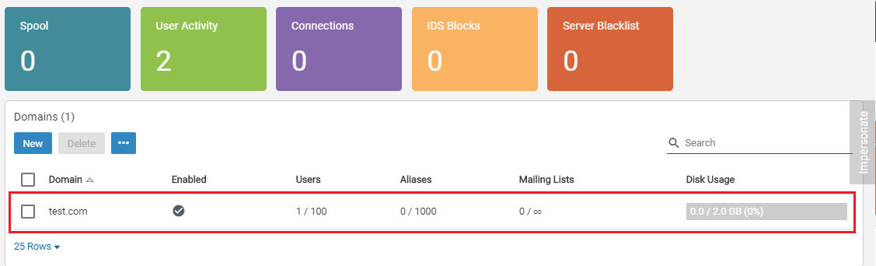
- Now, you have to click on the manage button.
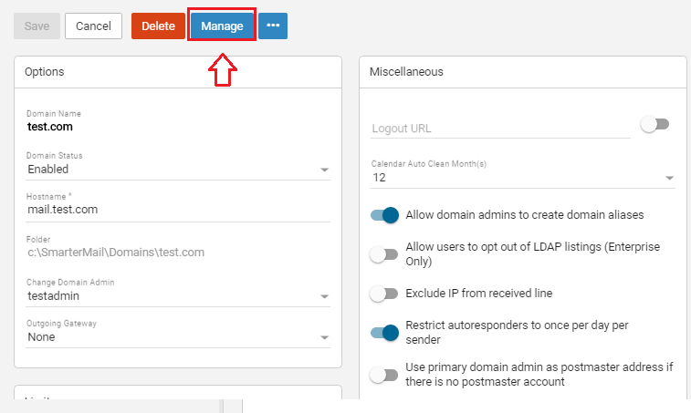

- clicking on the manage button you will get the following window. In this window, you have to click on Impersonate button. This will open a window.
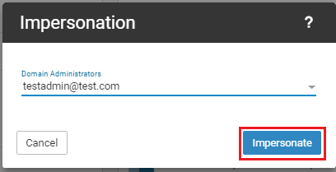
- Click on Accounts -> New to add/create a new email address.
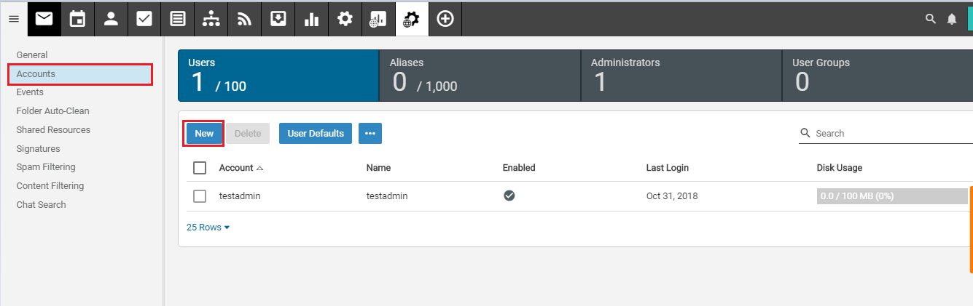
- Once you click on the new button you will get the following window. You have to fill all the details and click on the save button.
Username: (name of the email address which you want to add)
Password: Set a strong password.
Confirm Password: Enter the same password which you have set in the Password field.
Force password change at next login: You can tick on this option if you want to change the password of the email account on the next login.
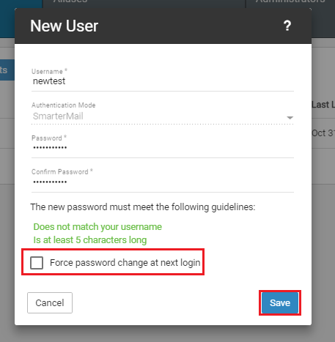
- clicking on the save button you will get the following tab. If you want to login in the email account(which you have just created) click on the Impersonate button. Click on the Cancel button if you don’t want to login and want to see email account created by you.
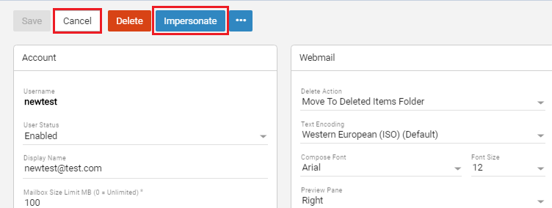

- Once you click on the cancel button you will able to see the email account which you have created. You can see the email account “newtest” created by us in the below image.
