How to add domain manually in Smartermail 16.
- Login into SmarterMail 16 with the domain administrator user.
- Once you are logged into SmarterMail web interface, you will see the SmarterMail 16 screen as below. Click on the New button as shown below. This will open a new prompt.
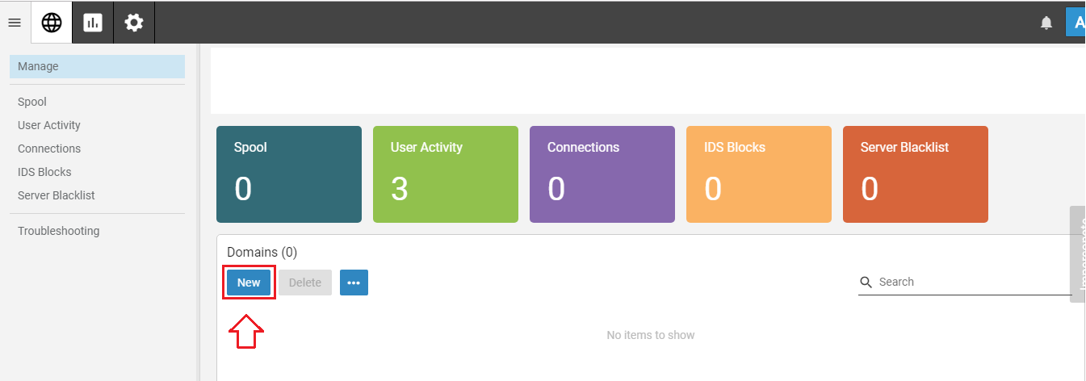
- Fill up the following details in add domain prompt.
Name - This is your fully qualified domain name (FQDN) e.g. test.com.
Hostname - Optional [It will be added automatically]
Folder - Optional [It will be added automatically]
Domain Administrator Username - The Domain Administrator user has more privileges than other users. This user has access to domain reports regarding space usage.
Domain Administrator Password - The password for the Domain Administrator.
Click on the Save button.
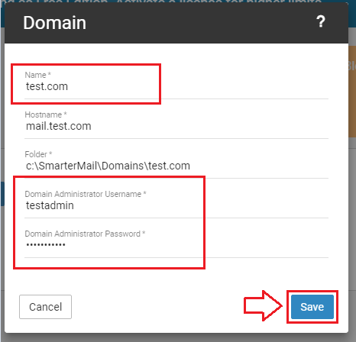
- After completing the above steps you will see domain manage settings. The default settings should work with no issues. Make sure Require SMTP Authentication is checked.
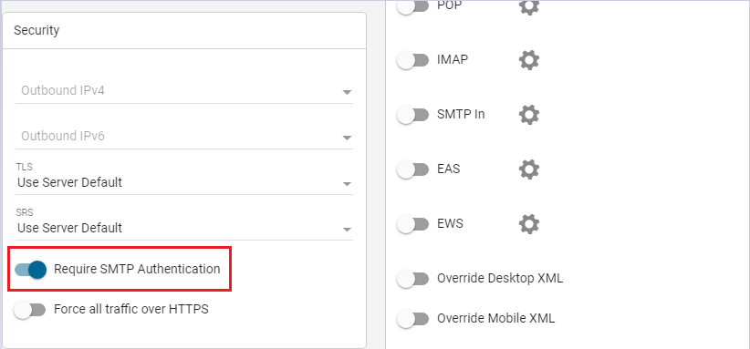
- You can set the limit for your domain like disk space, users, user aliases etc. 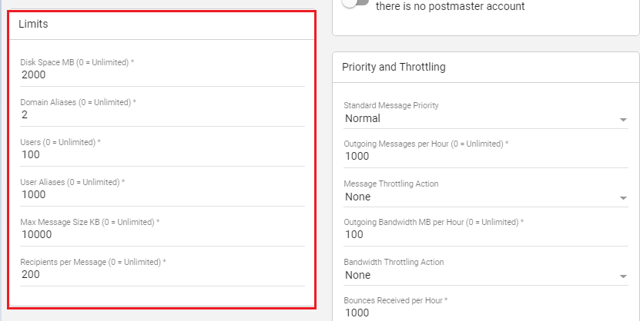

- All other settings are optional. You can set them up as per your requirement or leave the default settings as they are. Click on Save to apply the changes in SmarterMail.

