How to allow administrator login from a specific IP address in SmarterMail 16.
- Login into SmarterMail 16 dashboard with the domain administrator user.
- Click on Settings and select Administrators option from the left pane.
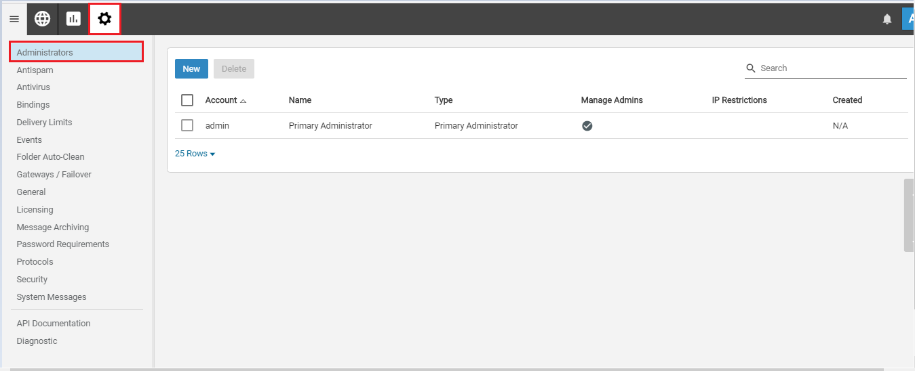
- Click on the admin user.
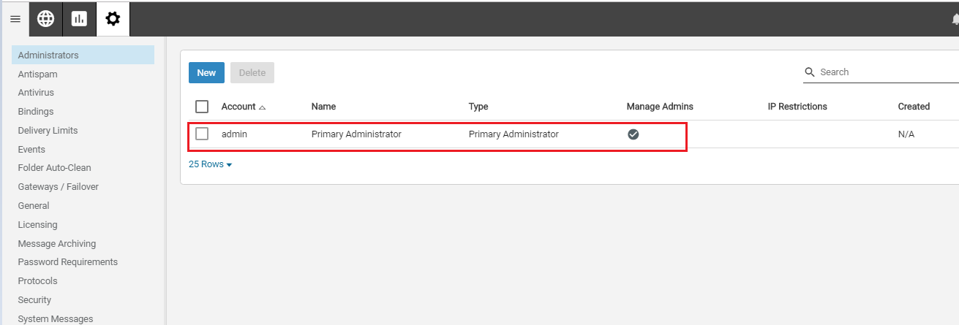

- Select Restrict login access by IP option. This will enable IP Restrictions + New Rule option, Click on it.
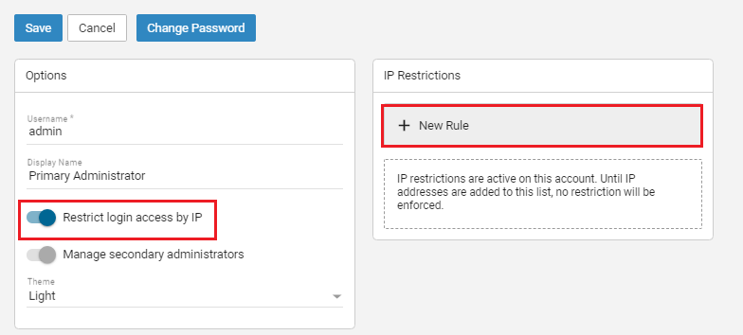
- Enter an IP address or range of IP addresses and add Description (optional). After then click on the Ok button.
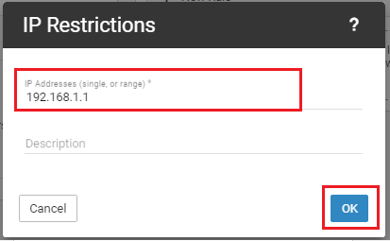
- Once you click on the OK button, the IP address will be added in the IP Restrictions field. Click on the Save button to save the changes.
