How to Change Email password from the User End In Smarter mail 16.

- Login into SmarterMail 16 with email account user
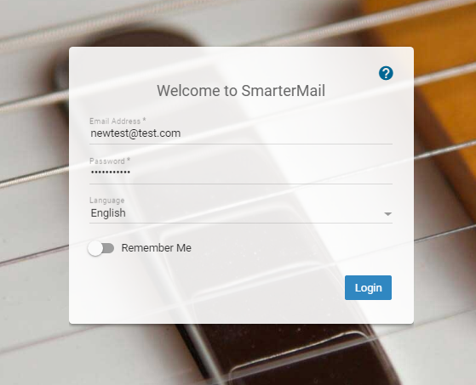
- Go to Setting Select Account and Select Change Password.
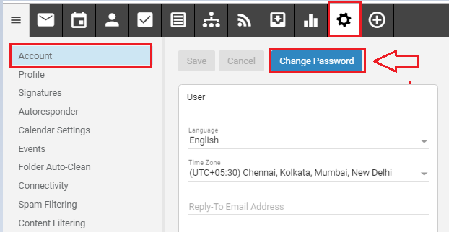

- Enter your Old Password. Type your New Password and re-type your Password.
- Click On Save.
