How to check disk usage of a Mail domain in SmarterMail 16.
- Login into SmarterMail 16 dashboard with the domain administrator user.
- Click on Domain Name for which you want to check mail disk usage.
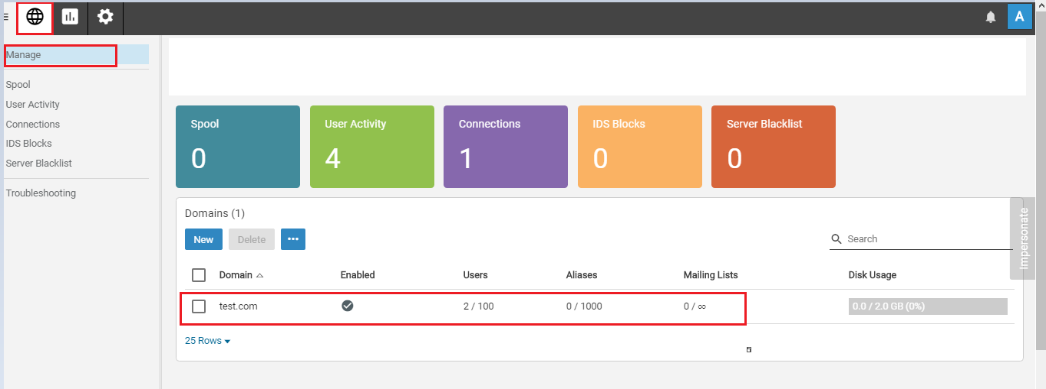
- Click on the Manage button.
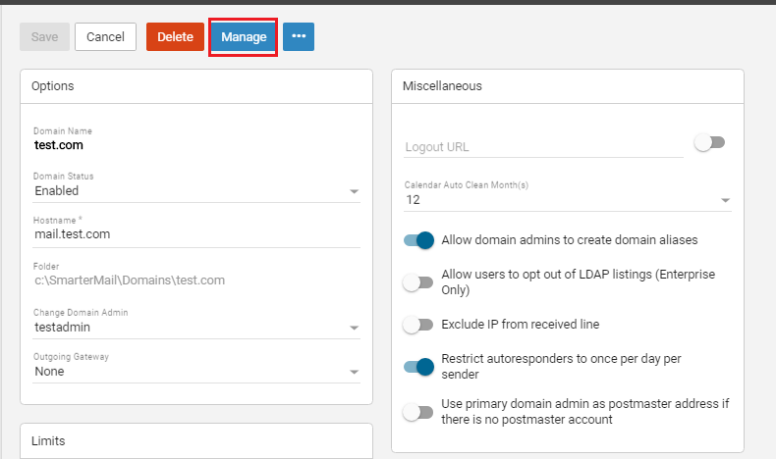

- Click on Impersonate button in Impersonation confirmation dialogue.
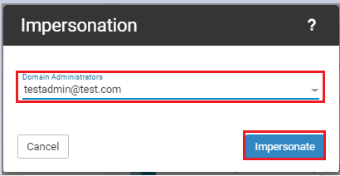
- Click on Domain Reports icon from the top menu bar.
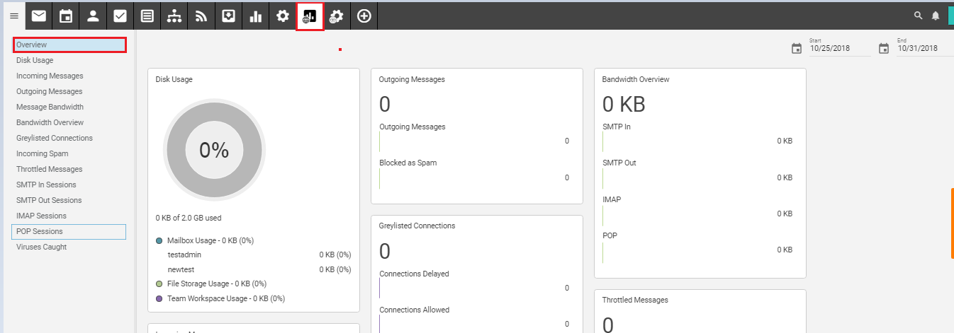
- Now, you would see the list of all mail accounts along with disk space usage
