How to Check report of email account in SmarterMail 16
- Login into SmarterMail 16 with email account user
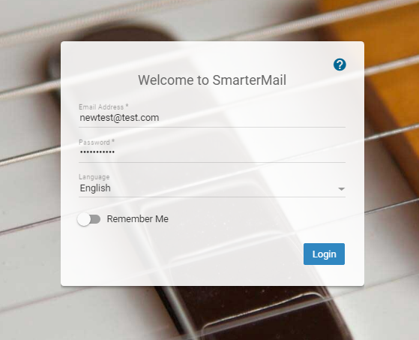
- Click on Report. Here you can check below report of Email account.
- Disk usage
- Incoming Messages
- Outgoing Messages
- Incoming Spam
- Viruses Caught
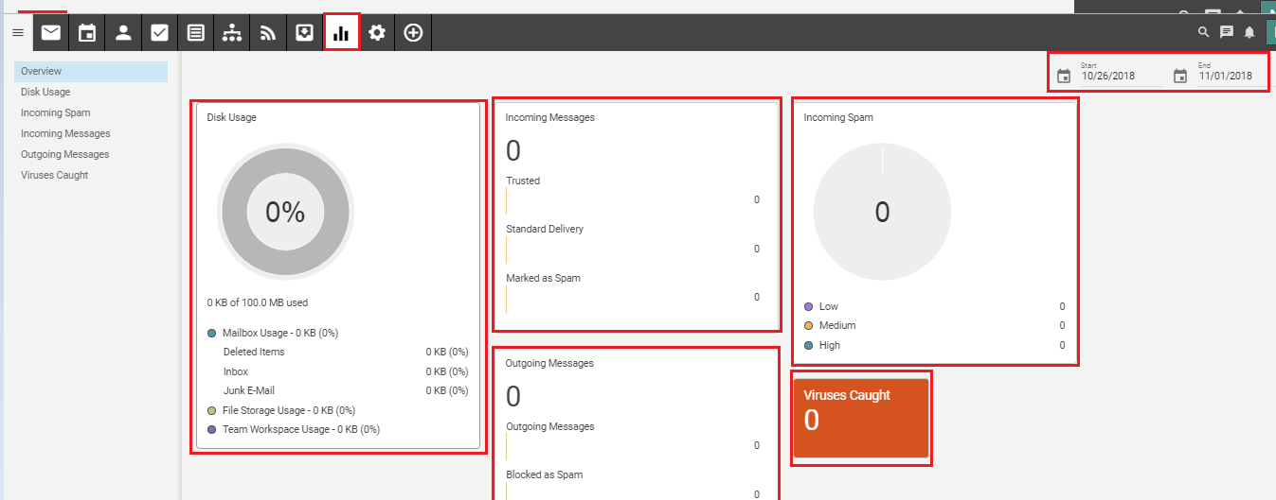 Also you can view the report of Particular Date. There option in Top of Right side.

