How to delete an email account in SmarterMail 16 by login as a domain administrator.
- Login into SmarterMail 16 dashboard with the domain administrator user.
- Once you login to the SmarterMail, you will get the following window. Click on the domain name of which you want to delete an email account.
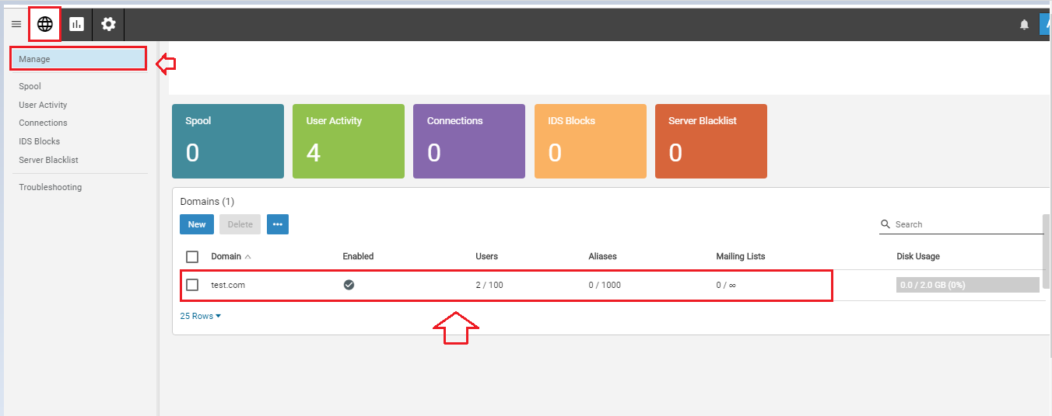
- Next, you have to click on the manage button.
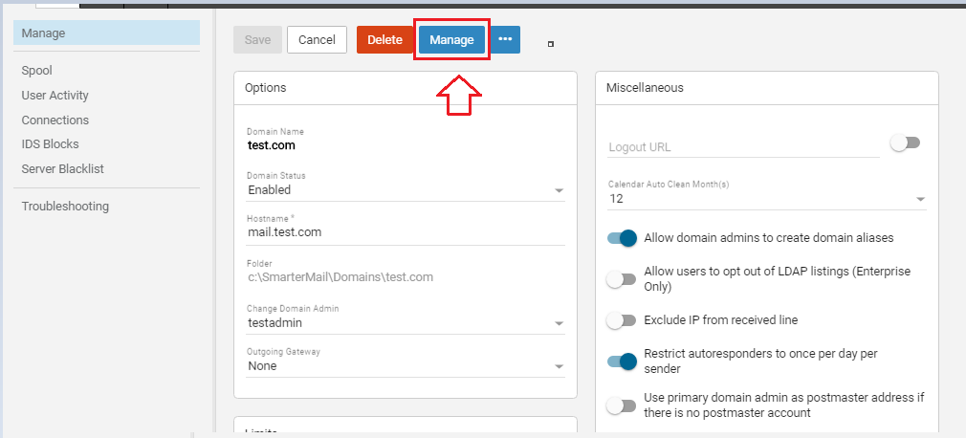

- Clicking on the manage button you will get the following window. In this window, you have to click on Impersonate button. This will open a window.
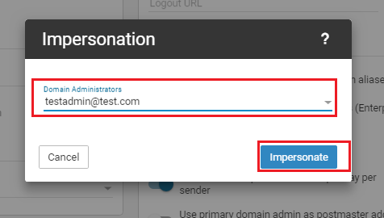
- In this windows, you can see all the email accounts which you have created.
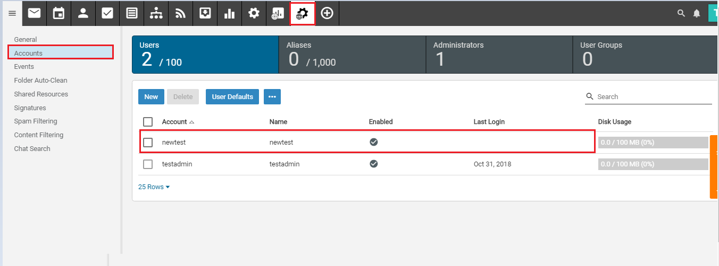
- Select the email account which you want to delete and click on the Delete button.
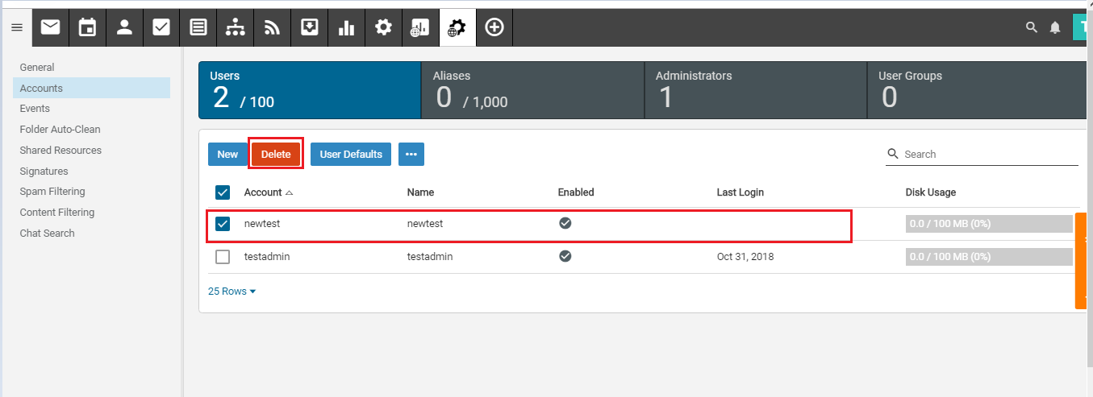
- Once you click on the delete button, the system will ask for the confirmation. If you have decided to delete it, click on the delete button. You can click on the cancel button if you want to abort the delete process.
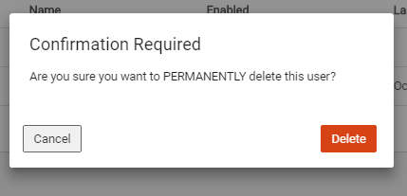
- Clicking on the delete button, the email account will be deleted and also removed from the email account list.
