How to Enable DKIM for Domain In Smarter mail 16.
- Login to the Smartermail using the admin user
- Click on Domain which you want to enable DKIM.
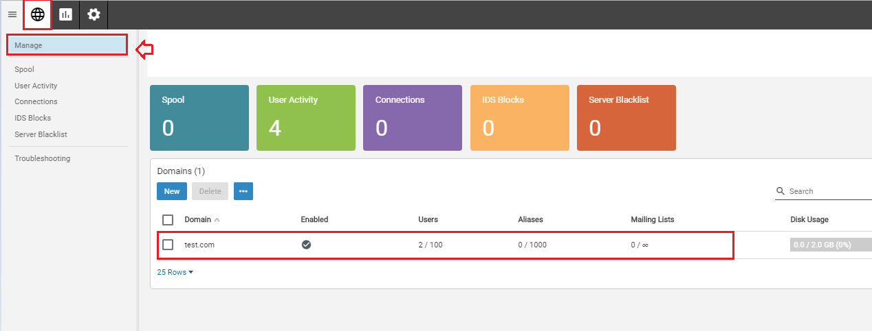
- Click on the Manage and impersonate with the default user.
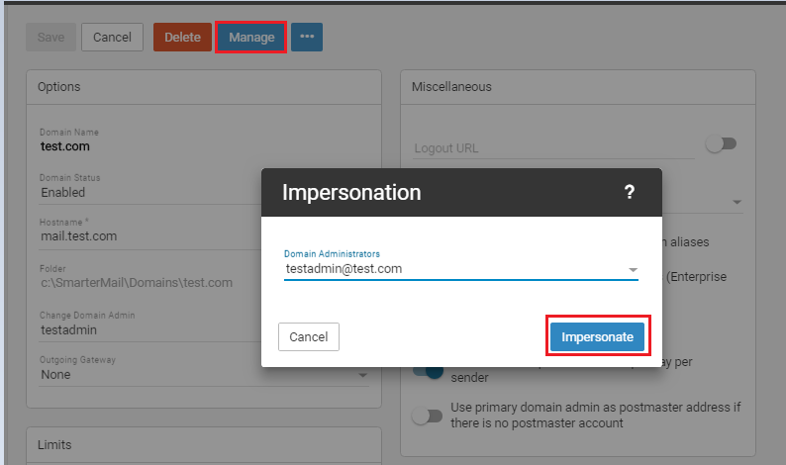
- Find Domain settings option and enter into it.
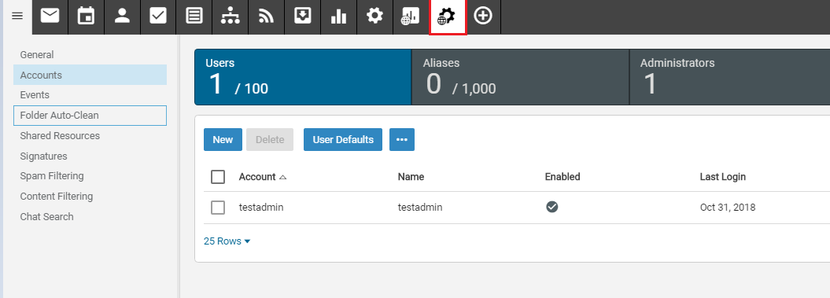

- You will find the option Email Signing. Click on the Enable button. This will generate the DKIM Record.
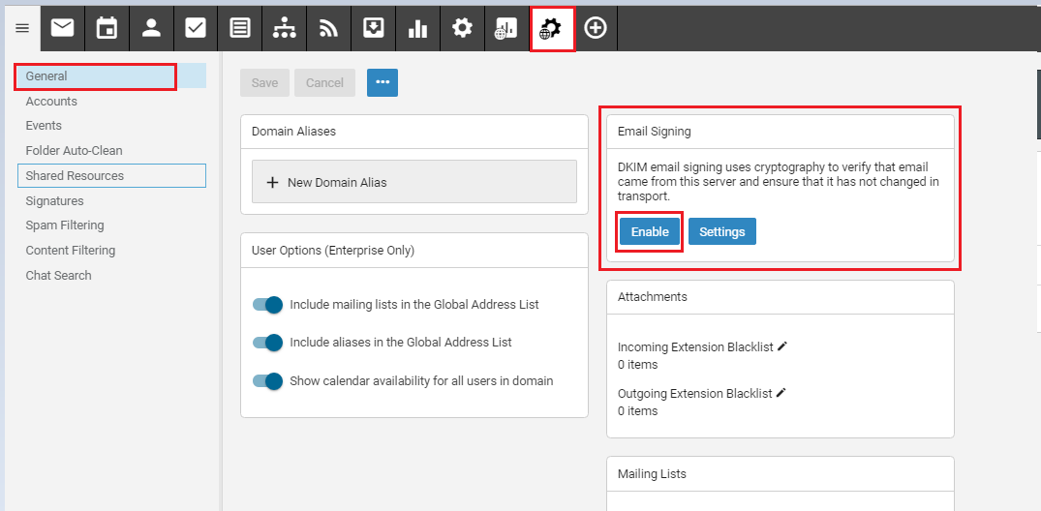
- Copy the "Text Record Name" and "Text Record Value"
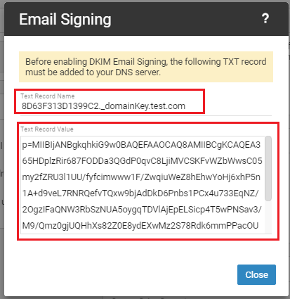

- Add it on DNS Zone of your Domain.

