How to enable or disable Graylisting from the SmarterMail by login as a domain administrator.
- Login into SmarterMail 16 dashboard with the domain administrator user.
- Once you login in the SmarterMail you will get the following window. Click on the domain name on which you want to disable Graylisting.
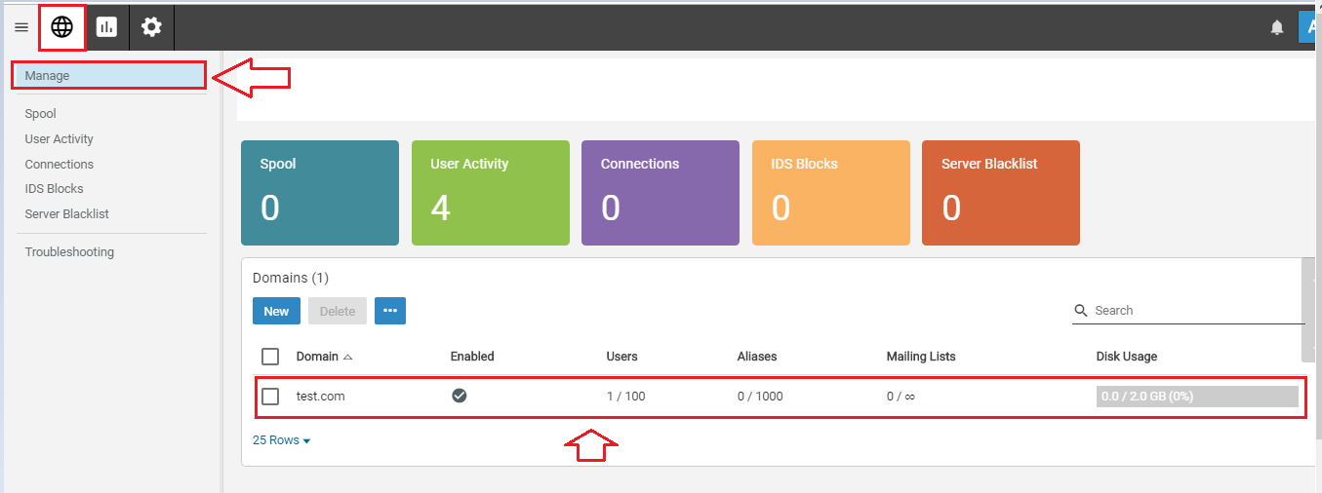
- Scroll down the screen and search the Email option.
- Under Email option, you will get disable Graylisting option. To disable graylisting you will have to switch the slider to the left. If you want to enable it again, you will have to switch the slider to the right.
