How to Login into Smarter Mail 16 Admin Panel.

- Browse the SmarterMail URL (http://xx.xx.xx.xx:9998) in your web browser. You will see a SmarterMail login page as below:
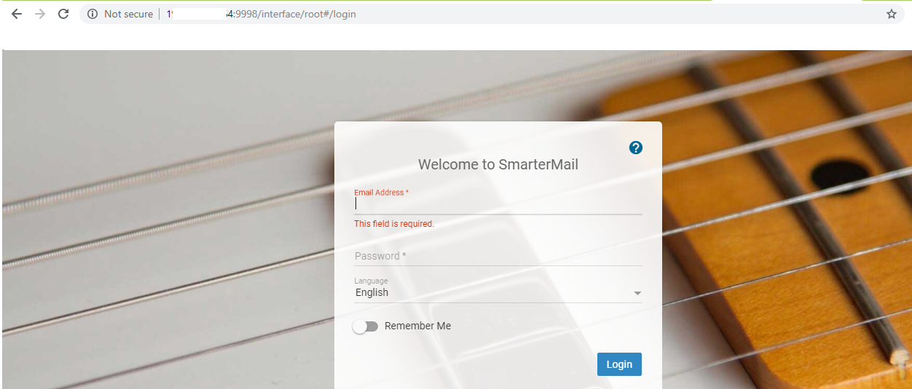
- Enter the login details in the below field and click on the login button.
Email address: admin
Password: Enter the Smartermail password.
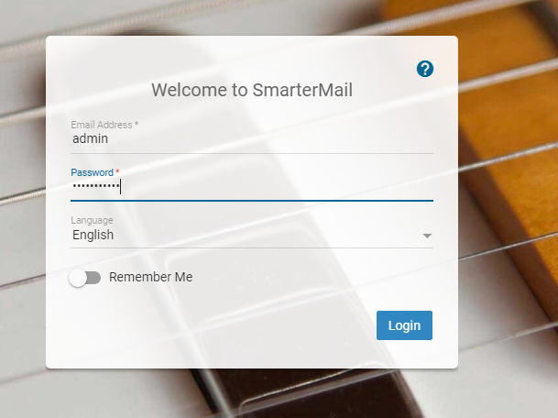

- You will see the following Dashboard after successful login.
