How to modify mail domain disk space Quota in SmarterMail 16.
- Login into SmarterMail 16 dashboard with the domain administrator user.
- Click on Domain Name for which you want to increase the disk limit.
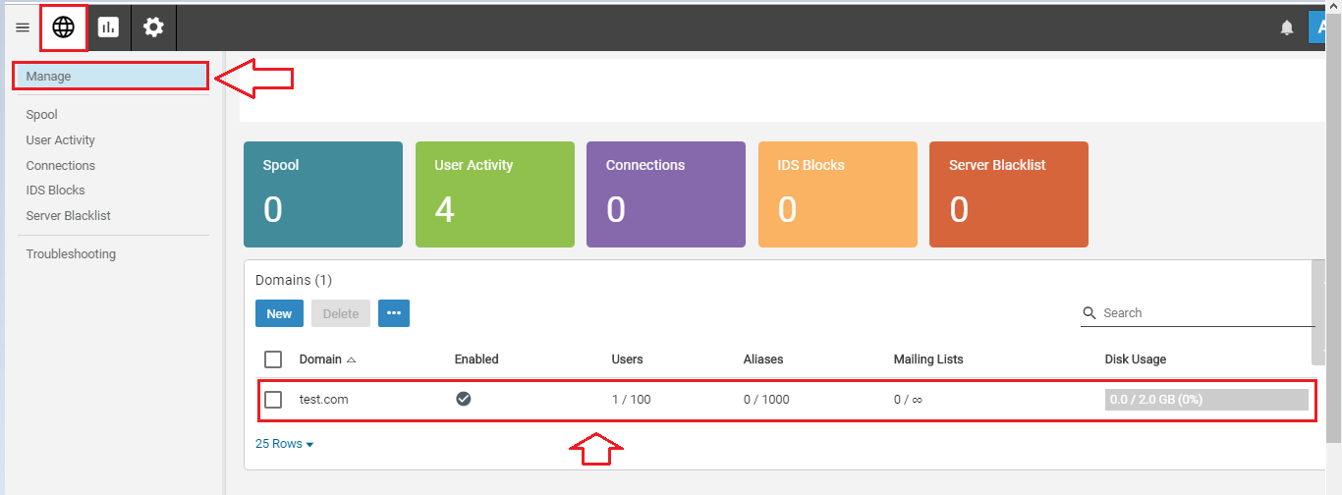
- Click on the Disk Space MB (0 = Unlimited) field and set the Disk Space Quota. For example Disk Space MB = 2048 (2048 MB = 2GB).

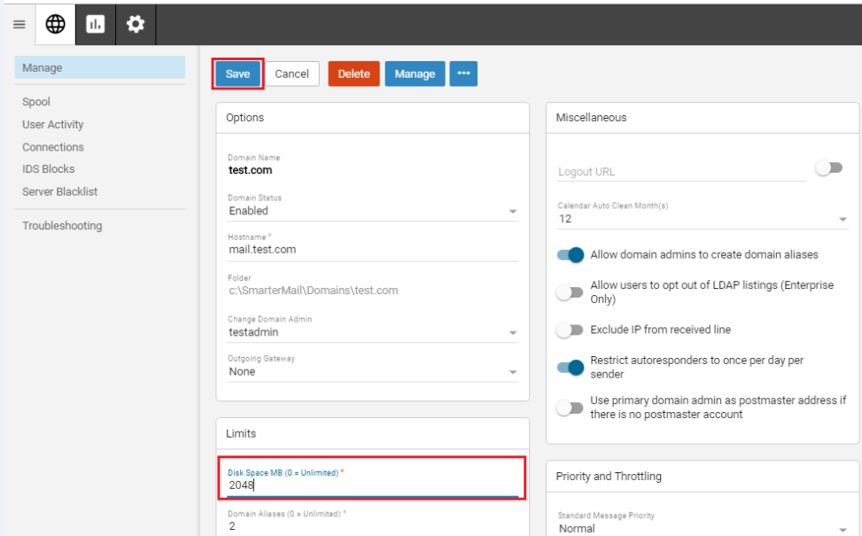
- Click on Save button to save the changes.

