How to reset admin user password in SmarterMail 16.
- Login to SmarterMail with the domain administrator user.
- Under Settings, click on Administrators. In right-hand side pane, you will see the admin user.
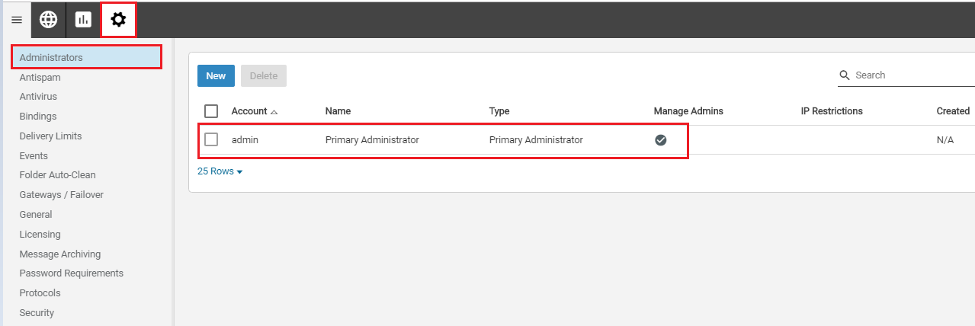
- Click on the admin user and click on the Change Password button.
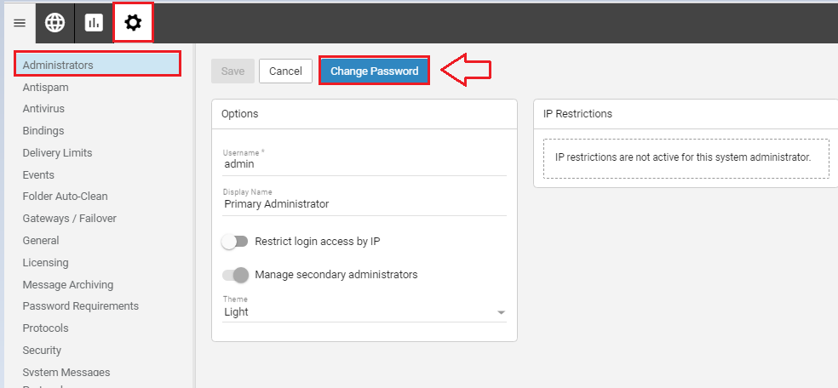
- Once you click on the change password button, you will get a new prompt. Enter New Password and Confirm Password.
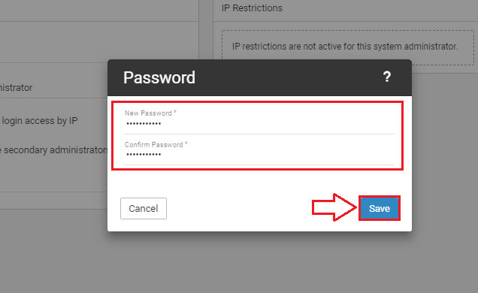
- Click on the Save button.

