How to reset an email account password from the SmarterMail 16 by login as a domain administrator.
- Login into SmarterMail 16 dashboard with the domain administrator user.
- Click on the domain name of which you want to reset the email account password.
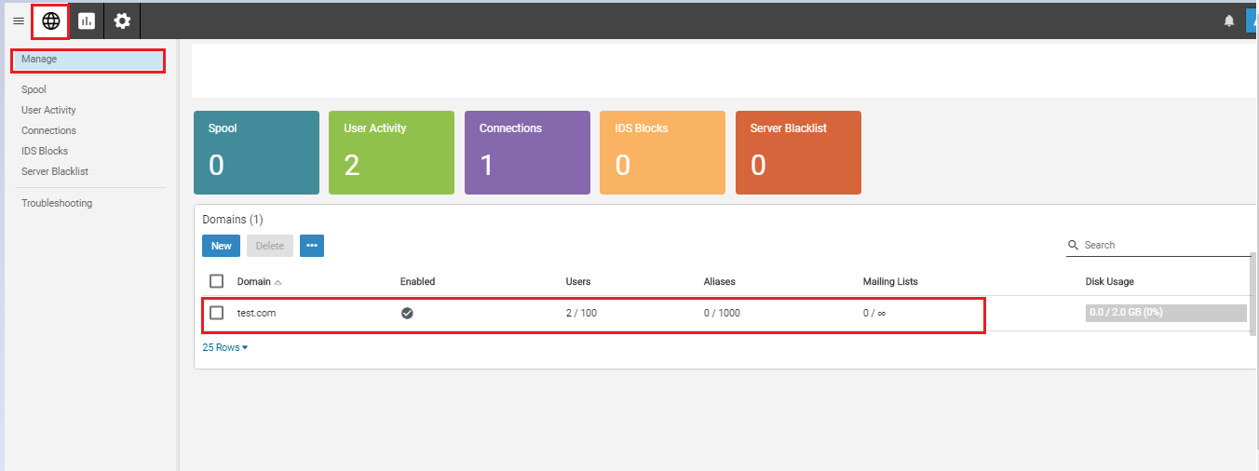
- Next, you have to click on the Manage button.
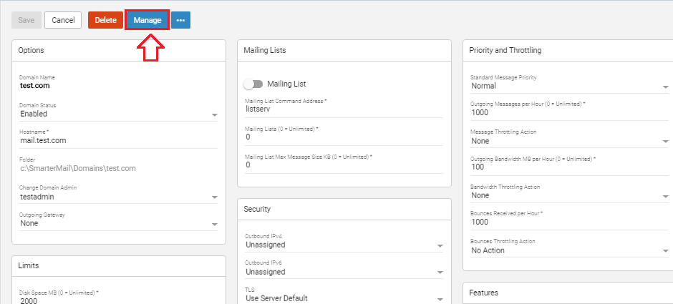

- Clicking on the Manage button, you will get the following window. In this window, you have to click on Impersonate button. This will open a window.
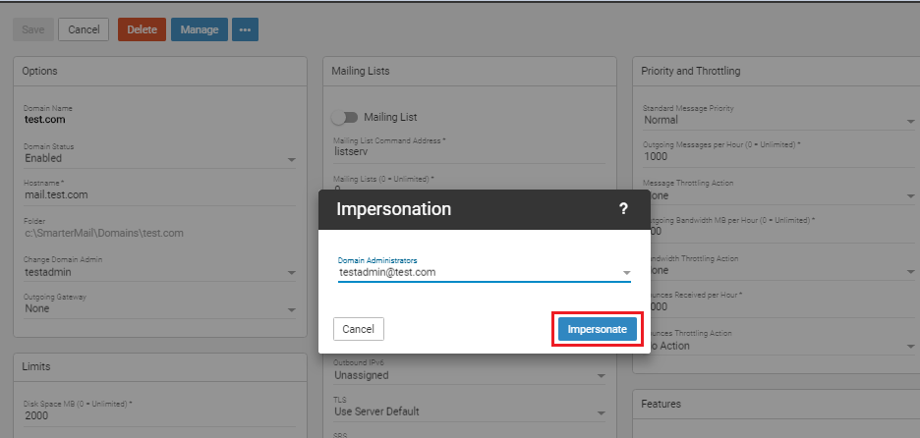
- In this windows, you can see all the email accounts which you have created.
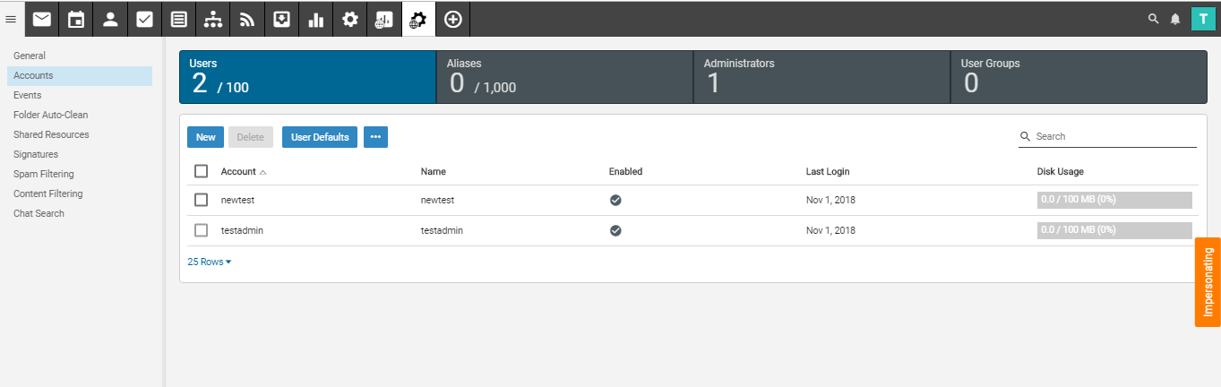
- Click on the email account of which you want to reset the password
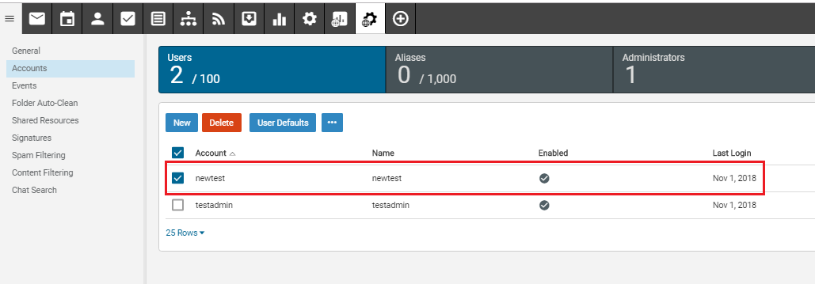

- Once you click on the email account, you will get the following windows. Click on the three-dot-button -> Change Password.
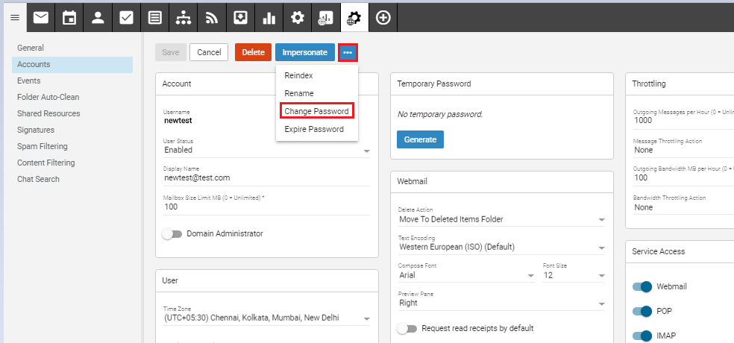
- You will get a new window. In that, you have to enter the password which you want to set and click on the Save button. If you want to abort the reset process, you can click on the Cancel button.
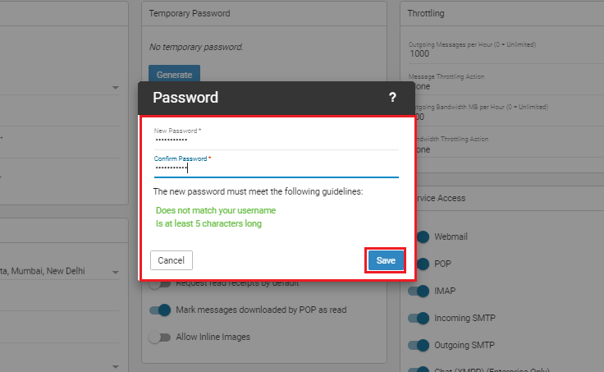
Once you click on the Save button, you will get a successful message at the bottom of the left screen. That means your password is successfully reset.

