How to set Auto-Clean email account in SmarterMail 16
- Login into SmarterMail 16 with email account user
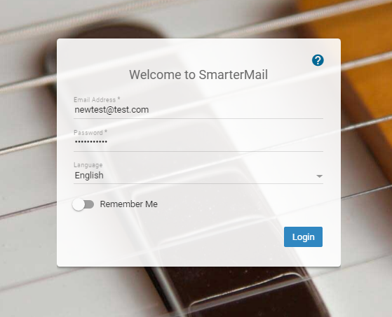
- Click on Settings Folder Auto-Clean Enable Override Auto-clean Setting Than Click on New Rule.

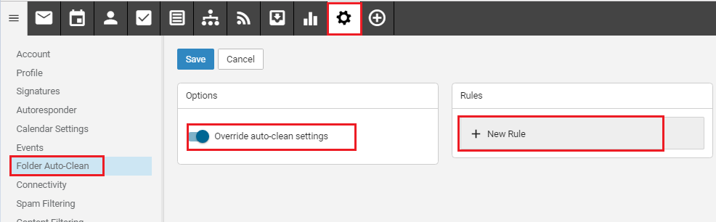

- After the Clicking New Rule, You will get below screen. Here you will get the Folder Option 1. Deleted Items 2. Junk Email 3. Sent Items.
Now you will need to select which email you want clean. Select the option.

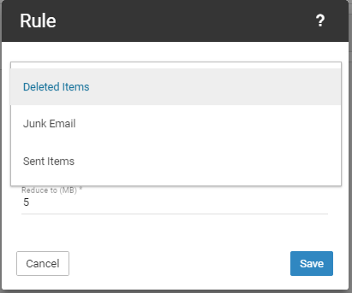
- Here I have select the Deleted Items. Now you will get type Option. Type By Size or Age of Email
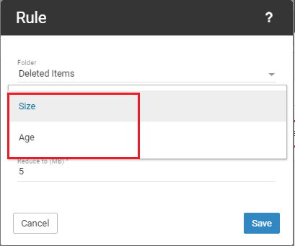

- Here I have select the Size , Here you can set the Folder Size limit (for ex. Your folder reach up to 10MB this will reduce to 5 MB. ) Set the Limit and Save.

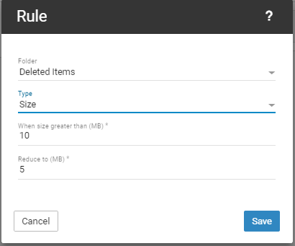
- Now, Other option is Age. Here you can set limit on Age of Email. (Ex. If you want to auto delete 30 days older email so can set the this option)
Than click On Save.
