How to set Autoresponder email account in SmarterMail 16
- Login into SmarterMail 16 with email account user
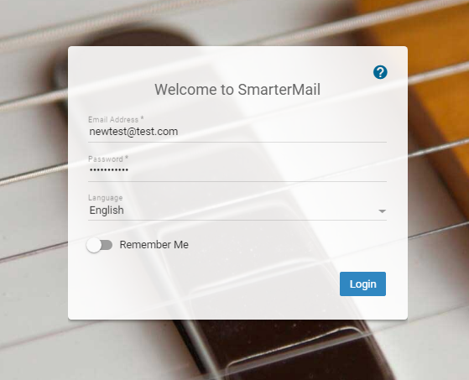
- Click on Settings Autoresponder
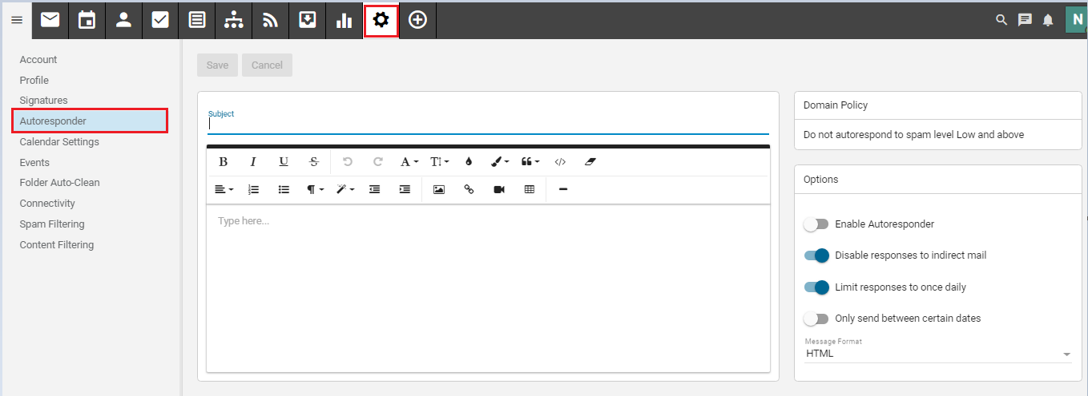

- Now you can Type the Subject and than below field you can type your massage.
Now Go option section in right site
- you can set enable or disable auto responder.
- Disable autoresponder to Indirect mail
- Limit responder to once daily
- Only send between certain dates.
Than click on Save

