How to set override Spam filtering for a particular email account in SmarterMail 16
- Login into SmarterMail 16 with email account user
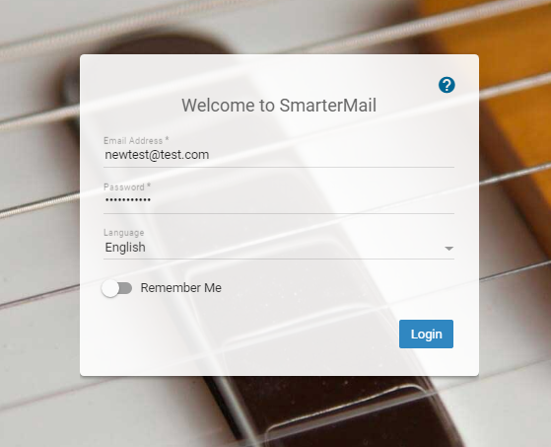
- Click on Settings → Spam Filtering.
- Select Override filter weights and actions for this domain from right-hand side options pane.
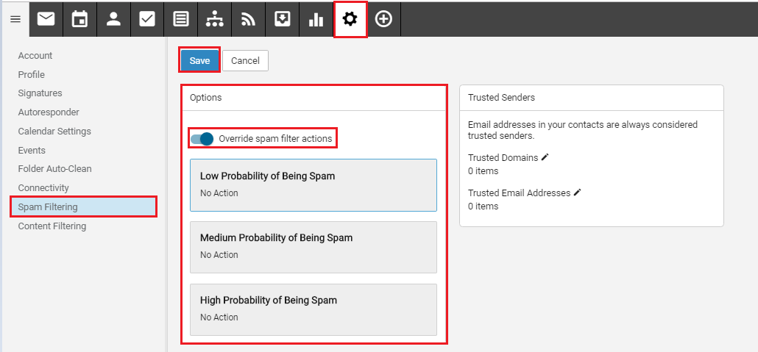

- You can set actions for the following options:
Low Probability of Being Spam.
Medium Probability of Being Spam.
High Probability of Being Spam.
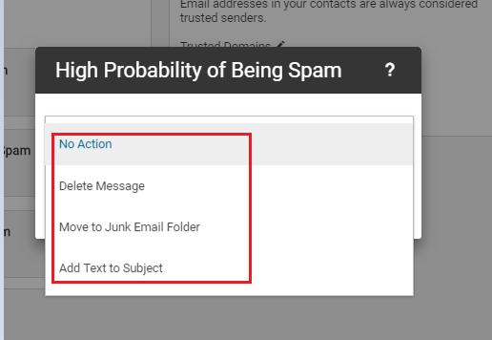
- Click on the option to set the action you want, below actions are available for the above options:
- No Action
- Delete Message
- Move to Junk email folder
- Add Text to Subject
- click on Save to apply changes.

