How to set Signatures email account in SmarterMail 16
- Login into SmarterMail 16 with email account user
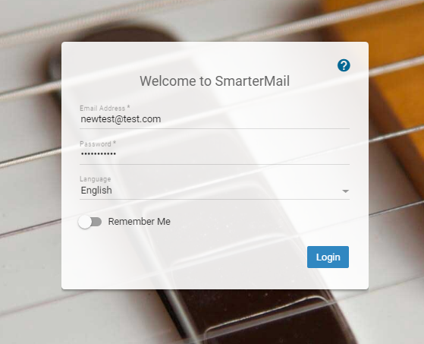
- Click on Settings Signatures Click on New Signature.
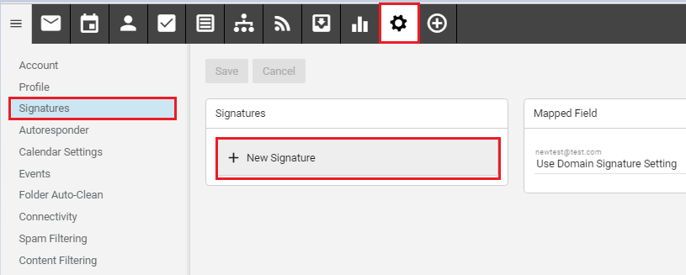

- Now you can Type Signature Name and than you can type other Details on body. As per below screenshot. Than click on Save.
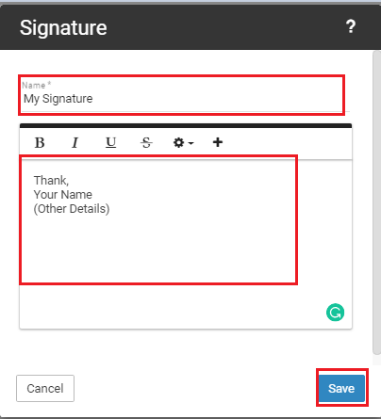
- Your Signature has been added now
